Predictive Modeling Report
Introduction
The objective of this analysis is to examine whether dietary intake influences blood pressure and cholesterol levels. Specifically, the study evaluates the impact of protein,sugar , fat and fiber consumption on these health outcomes. Previous research has shown that diets high in trans and saturated fats can increase unhealthy cholesterol levels and elevate blood pressure. In contrast, dietary patterns rich in whole grains, fruits, healthy fats , and vegetables are commonly associated with improved cholesterol measurements and lower blood pressure .
The data used in this analysis come from the National Health and Nutrition Examination Survey (NHANES), conducted in the United States between 2021 and 2023. NHANES employs a stratified sampling design to produce a sample that represents the U.S. population. At Mobile Examination Centers (MECs), trained personnel performed in-person interviews using the Computer-Assisted Personal Interview (CAPI) technology to gather dietary intake data (DR1TOT_L).
The survey included participants of all ages, ranging from infants to older adults. For children under six years of age, dietary information was provided by a proxy respondent who was most familiar with the child’s food intake. Children between the ages of six and eight were interviewed with a proxy present, while children between the ages of nine and eleven took part with a proxy's help. Individuals who were twelve years of age and older reported their personal intake.
At the MECs, blood pressure data (BPXO_L) were also gathered, with an emphasis on people eight years of age and older. Cholesterol measurements (TCHOL_L) were obtained both at MECs and through laboratory analyses, targeting participants aged six and older. Demographic information (DEMO) was collected using the CAPI system, ensuring consistent data collection methods across all components of the survey. Each mentioned dataset focuses on particular population groups depending on age and the objectives of the study.

Data Preparation and Analysis Methodology
To conduct this analysis, relevant variables were carefully selected and merged from the cholesterol, blood pressure, dietary, and demographic datasets from NHANES. After merging these datasets, the final combined dataset consisted of 208 variables and 7,801 participants . From this dataset, seven variables were selected for the analysis: systolic blood pressure, cholesterol, diastolic blood pressure, protein, sugar, fiber and fat . These factors were selected because they are significant indicators of cardiovascular risk and major dietary components that are frequently studied in public health research.
Each unmeasurable value within the dataset was treated as NaN to reduce potential computational errors. In NHANES datasets, missing values are typically represented by a “.”, which can lead to errors during statistical analysis if not properly handled. To address this issue, missing values in continuous variables were replaced with the calculated mean of their particular column. This method helps maintain the overall distribution of the data while avoiding the introduction of extreme values that could distort the results. Mean imputation is particularly preferred when variables are approximately normally distributed and enables all participants to remain included in the analysis.

After handling missing values, the dataset was reduced to a sample of 200 participants to allow for a more manageable and controlled analysis. Using this smaller sample size provides a balance between statistical power, analytical accuracy,and computational efficiency.
Exploratory Data Analysis (EDA)
A correlation matrix was created to identify the variables that were strongly associated with the dependent variables . Protein and fiber appeared to have the strongest associations with cholesterol. By binding to bile acids in the digestive tract, fiber helps reduce cholesterol. This lowers the risk of cardiovascular disease and supports heart health. Different protein sources have varying effects on cholesterol levels. While high-fat animal protein may increase cholesterol, lean proteins can lower it.These factors were selected because they are significant indicators of cardiovascular risk and major dietary components that are frequently studied in public health research.
Protein and fat were most strongly correlated with blood pressure. Overindulging in fat can lead to weight gain and clogged arteries, which can raise blood pressure. On the other hand, eating good fats helps lower inflammation and enhance cardiovascular health. Protein increases cardiovascular health and muscular mass, which in turn lowers blood pressure. Very extreme protein intake may increase blood pressure due to its association with sodium and saturated fats .
To statistically summarize these relationships, Pearson correlation coefficients were calculated. The majority of p-values were not significant, and all factors had modest linear associations with blood pressure and cholesterol. This implies that the reported results cannot be fully explained by linear relationships alone. This suggests that in order to identify possible non-linear or interaction effects, more sophisticated modeling techniques could be required.

Regression Modeling
To further explore the mentioned correlations, linear regression models were built. Both single and multiple linear regression models have low R2 values and poor performance. To compare projected and actual values, residual plots and distribution graphs were made with the Seaborn library. The correlations between the chosen food consumption factors and cardiovascular outcomes appear to be nonlinear, according to these diagnostic plots. I used the MinMaxScaler function to standardize each variable's values and eliminate any outliers in order to enhance model performance. The normalization procedure ensures that variables with various scaled values contribute to the model equally.

To take any non-linear relationships into consideration, polynomial regression (degree=2) was employed. We could find tiny curves in the data that might help with blood pressure and cholesterol prediction by adding squared terms to this model. Additionally, patterns that might not be addressed by linear modeling can be found using polynomial regression. This offers a deeper understanding of the potential effects of dietary intake on health outcomes.

Regularization Models
A modeling pipeline was developed to fit the Ridge, Lasso, and Elastic Net regression models. Both the Ridge and Lasso models were implemented using an alpha value of 1.0, which helps control overfitting while still allowing the models to capture meaningful patterns in the data. The Elastic Net model was fitted with a L1 ratio of 0.2 and alpha value of 1.0 and , combining elements of both Ridge and Lasso regularization.
The Ridge model demonstrated relatively better performance when predicting blood pressure but performed poorly when predicting cholesterol levels. Similarly, the Lasso and Elastic Net models showed moderate performance for blood pressure predictions but weak performance for cholesterol. Regularization methods are particularly useful when predictor variables are highly correlated, as they reduce the magnitude of large coefficients and help lower model variance. However, the dietary variables included in this analysis provided limited predictive power. This suggests that incorporating additional factors such as lifestyle behaviors, body mass index, age, and genetics may improve the predictive capability of regularization-based models.
Model Performance and Interpretation
Overall, the models demonstrated limited success in predicting cholesterol levels. Among the models tested, multiple linear regression performed slightly better than the others ( R² = 0.0373, MSE = 0.0458) . Despite this, the predictive power remained weak, indicating that the selected dietary variables have only a minimal linear relationship with cholesterol. Suggesting that additional predictors may be needed to improve accuracy of the model.
For blood pressure prediction, the single linear regression model explained very little variance, with a R² value of 0.0026 and mean squared error of 0.0333 . Multiple linear regression showed a small improvement, producing a R² value of 0.0265 and MSE of 0.0388. Polynomial regression achieved the best performance among the models, with an R² value of 0.0514. In contrast, the Ridge, Lasso, and Elastic Net models performed poorly when predicting blood pressure measurements. Overall, the results suggest that the dietary intake variables included in this study had only a limited influence on blood pressure outcomes.
Challenges and Limitations
A key limitation of this study was the relatively small sample size of 200 participants. This limited sample may not accurately represent the broader population and could introduce selection bias. In addition, the blood pressure measurements used were collected on the first day , which may not reflect true blood pressure levels because of natural daily fluctuations. The dietary data were also self-reported, making them susceptible to recall bias, measurement error,and inconsistencies in reporting. These factors may have contributed to the reduced performance of the predictive models. Future research could improve results by incorporating repeated measurements, using larger sample sizes, and including additional variables to strengthen the models.
Conclusion & Future Work
In conclusion, this analysis indicates that dietary intake of sugar, protein, fiber and fat has only a weak linear association with blood pressure measurements and cholesterol levels. Predictive performance was marginally enhanced and some moderate nonlinear patterns were captured by polynomial regression. However, the regression models' overall explanatory power stayed low. Additionally, the study's regularization models performed poorly when it came to forecasting the results.
These results imply that cardiovascular outcomes cannot be reliably predicted by the chosen dietary variables alone. Blood pressure and cholesterol levels are probably more influenced by other factors like age, heredity, sodium intake,body mass index (BMI),physical exercise, and more general lifestyle choices.

Bigger sample sizes, repeated measurements, and the addition of more covariates to enhance model performance could all be advantageous for future studies. Furthermore, complex, nonlinear, and interactive interactions between dietary intake and cardiovascular health may be better captured by using more sophisticated machine learning techniques. Deeper understanding of how many dietary and non-dietary factors interact to affect cardiovascular risk may be possible with the help of such techniques.

Variable Name | Variable description | Data Type | Mean | Standard deviation | Minimum value | Maximum  Value
LBXTC | Total Cholesterol (mg/dL) | Numerical | 182 | 39 | 62 | 438
BPXOSY1 | Systolic - 1st oscillometric reading | Numerical | 119 | 18 | 61 | 232
BPXODI1 | Diastolic - 1st oscillometric reading | Numerical | 73 | 12 | 33 | 142
DR1TPROT | Protein (gm) | Numerical | 73 | 34 | 0 | 459
DR1TSUGR | Total Sugar (gm) | Numerical | 98 | 60 | 0 | 953
DR1TFIBE | Dietary fiber (gm) | Numerical | 16 | 9 | 0 | 127
DR1TTFAT | Total Fat (gm) | Numerical | 83 | 40 | 0 | 506

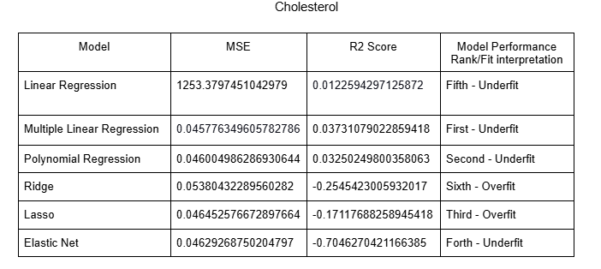
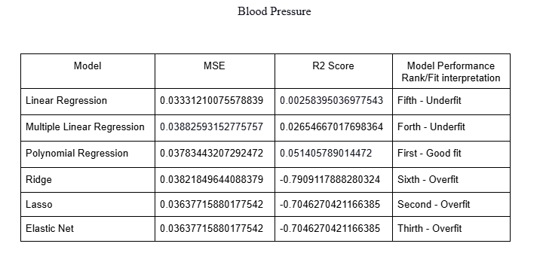
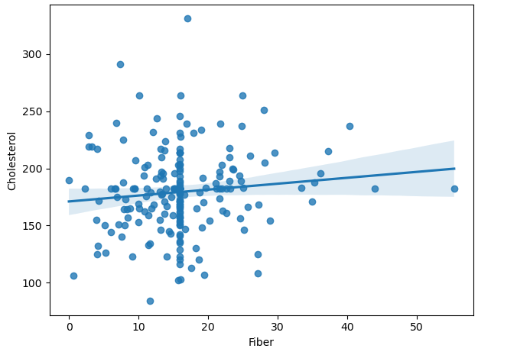
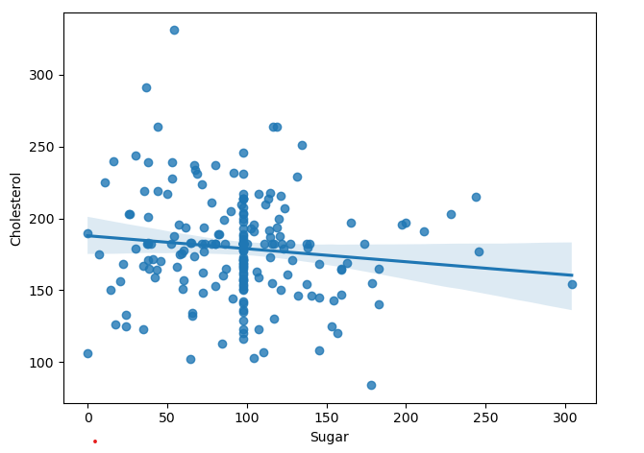
Linear Relationship Plots (Coefficient Correlation)

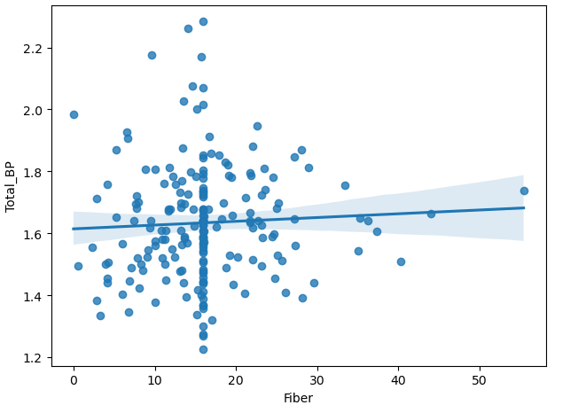
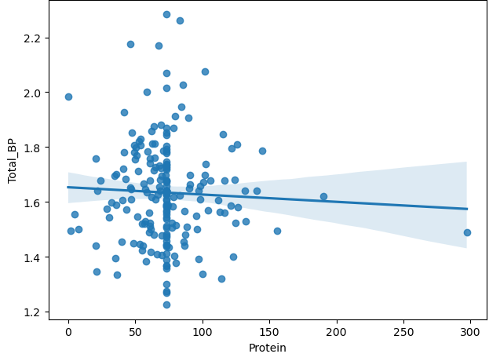

Single variable Linear Regression comparison plots
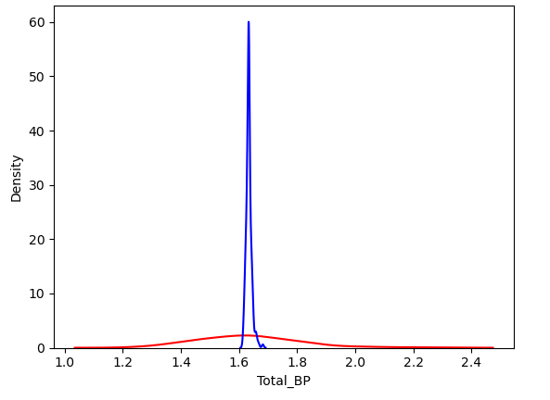
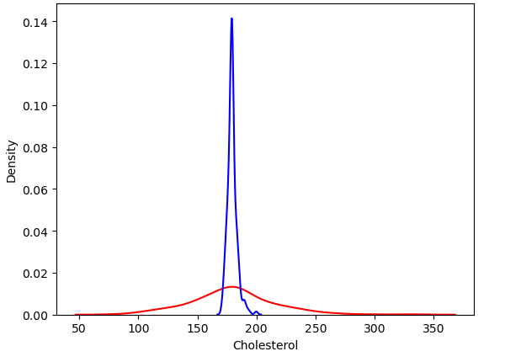
Sugar = Cholesterol (Predicted vs Actual values) Fiber = Cholesterol (Predicted vs Actual)

Fiber = Blood Pressure Predicted vs Actual values) Fiber =Blood Pressure (Predicted vs Actual values)
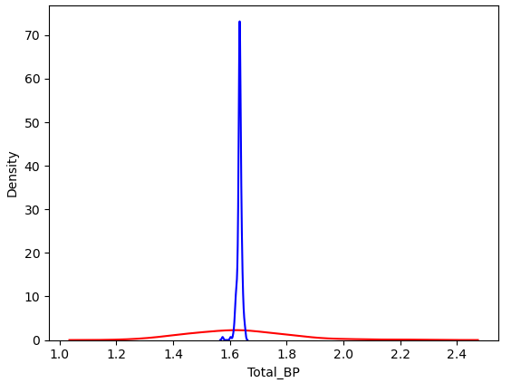
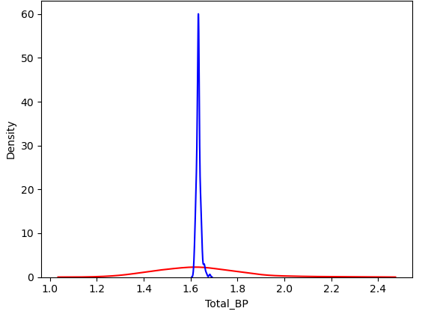

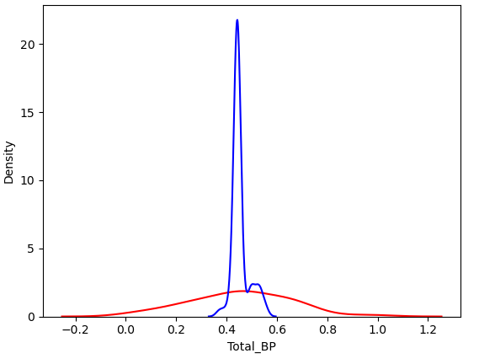
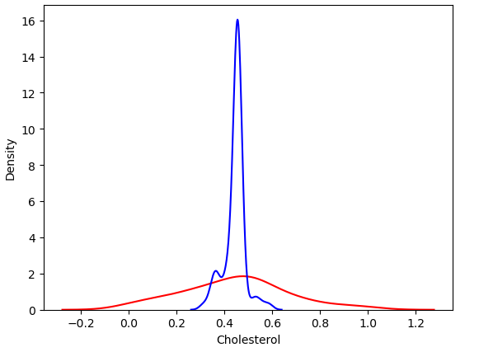
Multiple Variable Linear Regression comparison plots

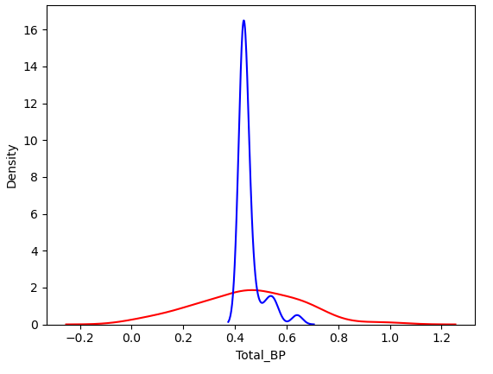
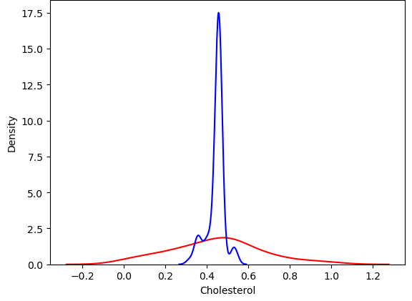
Polynomial( Degree = 2) comparison plots

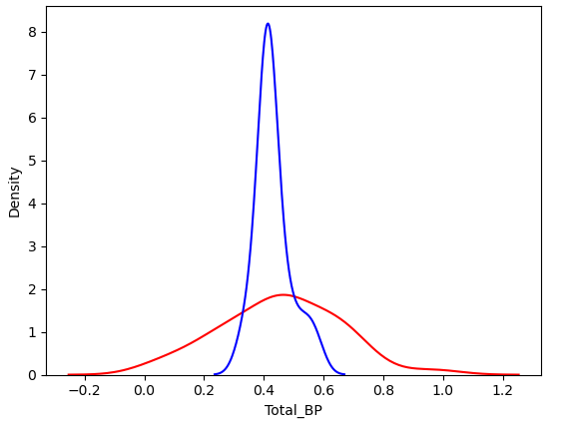
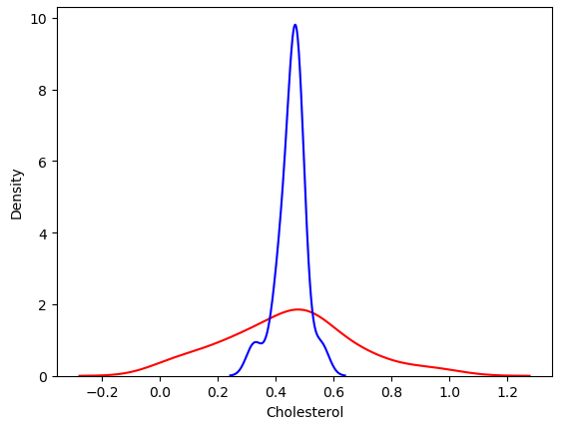
Ridge Comparison Plots

References

- Sakurai M, Stamler J, Miura K, Brown IJ, Nakagawa H, Elliott P, Ueshima H, Chan Q, Tzoulaki I, Dyer AR, Okayama A, Zhao L; INTERMAP Research Group. Relationship of dietary cholesterol to blood pressure: the INTERMAP study. J Hypertens. 2011 Feb;29(2):222-8. doi: 10.1097/HJH.0b013e32834069a5. PMID: 21045731; PMCID: PMC3075799.​

- MacGregor GA. Nutrition and blood pressure. Nutr Metab Cardiovasc Dis. 1999 Aug;9(4 Suppl):6-15. PMID: 10715833.​

- Mastering ridge regression: A key to taming data complexity | by Bernardo Lago | Medium. (n.d.). https://medium.com/@bernardolago/mastering-ridge-regression-a-key-to-taming-data-complexity-98b67d343087 ​

- Lasso. scikit. (n.d.). https://scikit-learn.org/stable/modules/generated/sklearn.linear_model.Lasso.html ​

